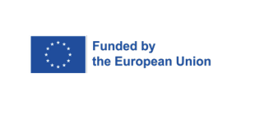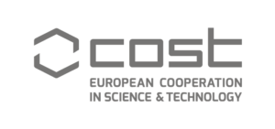

**6th Profeedback Conference**

**“Business Development, SMEs, Entrepreneurship, Competitiveness”**

Athens, 19th September 2024

|  |  |  |  |  |
| --- | --- | --- | --- | --- |
| **Preliminary agenda** | | | | |
| **Day 1** | **Thursday, 19th of September, 2024** | | |  |
| ***MORNING*** | **Registration** | | | 8:30-9:00 |
| **Opening session**  **Gábor BALÁS**, Action Chair  **Stelios KOTSIOS**, President of the Department of Economics, National and Kapodistrian University of Athens (tbc) | | | 9:00 – 9:30 |
| **Keynote speakers**  **Tassos GIANNITSIS**, Professor Emeritus Economics, National and Kapodistrian University of Athens  **Dana Adriana PUIA MOREL**, SME policy co-ordination, DG GROW European Commission | | | 9:30– 10:30 |
| ***Coffee Break*** | | | 10:30-10:45 |
| **Panel no. 1**  **(4 papers)** | | | 10:45–12:15 |
| **Panel no. 2**  **(3 papers)** | | **Panel no. 3**  **(3 papers)** | 12:15-13:25 |
| ***Lunch*** | | | | 13:25–14:25 |
| ***AFTER NOON*** | **Keynote speakers**  **Christos GENAKOS**, Professor of Economics and Policy, Director of the MPhil in Technology Policy Programme, Cambridge Judge Business School  **David AUDRETSCH**, Professor at the School of Public and Environmental Affairs at Indiana University, Director of SPEA's Institute for Development Strategies | | | 14:25-15:25 |
| ***Coffee Break*** | | | 15:25-15:40 |
| **Panel no. 4**  **(4 papers)** | **Panel no. 5**  **(4 papers)** | | 15:40– 17:10 |
| **Closing session**  Gábor BALÁS, Action Chair | | | 17:10 – 17:30 |

**VIRTUAL LINK:** [https://teams.microsoft.com/l/meetup-join](https://teams.microsoft.com/l/meetup-join/19%3ameeting_ZTYyZDFmMjQtODU2Yy00NGI0LWFhZDctMDBmN2ZiOGU0ZTI1%40thread.v2/0?context=%7b%22Tid%22%3a%222349d6df-afa2-4265-8cd6-3cb2ed773331%22%2c%22Oid%22%3a%222cf77a2c-c587-4eb3-8397-12d4b4ea8080%22%7d)