**6th Profeedback Conference**

**“Business Development, SMEs, Entrepreneurship, Competitiveness”**

**General Information**

Location: "Kostis Palamas" Building

Address: 48 Akadimias str., Athens, Greece

Nearest metro station: Panepistimio, Metro 2

Date: September 19, 2024

**Time zone**

Athens is in the EEST (Eastern European Summer Time, UTC+3).

**Airport Transfer / Transportation in Athens**

The venue and all proposed hotels are in the city centre. The fastest way to reach the city centre is by using **Metro** line 3 (M3, blue line). The blue line connects the Airport with Athens's central stations at Syntagma and Monastiraki. The venue and hotels are walking distance from Syntagma Square. These two stations along with the Acropolis Station (M2, red line) define the historic centre of Athens. You can purchase Ath.ena ticket (rechargeable ticket) from the ticket machines (Automatic Sale/Recharging Machines) within the stations. You can use credit cards or cash. In the automatic purchasing machines, you have the option to buy a one-way ticket (90 minutes), daily tickets etc. Options are available in English on the screen.

The ticket from/to airport metro station is a separate ticket (16€ round trip, 9€ one way). Alternatively, you can take the **bus line X95** from the airport to the city centre, Syntagma Square (5.50€ one way).

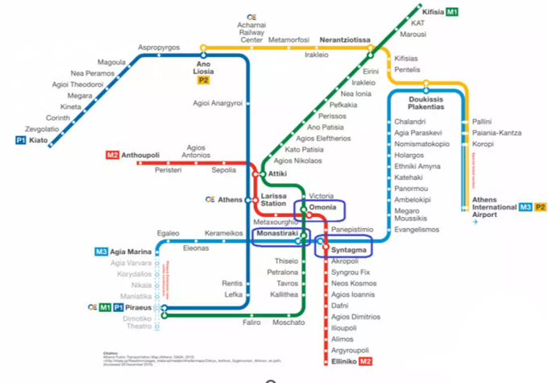

**Taxi**: From the airport to the city centre approximately 40-60€ (subject to time of arrival and traffic): Approx. 30 km/35 minutes - 1 hour. Taxis are queuing after exiting the airport. During your stay in Greece, you can also use the freenow app for ordering a taxi service.

**Accommodation**

There is a wide range of hotels and Airbnb in Athens. Since September is still high tourist season, please make a hotel reservation as soon as possible. The following hotels are in walking distance from the venue:

* [Arcade Hotel Athens](https://www.arcadehotel.gr/)
* [The Vault Athens](https://www.thevaultathens.com/)
* [Bob W Eolou](https://www.booking.com/hotel/gr/blend.el.html)
* [JV Athens](https://www.booking.com/hotel/gr/v-j-house-athens.el.html)
* [AthINN Residence](https://www.booking.com/hotel/gr/athinn-residence-athena.el.html)

**Meals**

**Coffee and refreshments during the event**

Coffee and refreshments will be provided by the organizer during the conference.

**Lunch**

Lunch is not covered by the organizer. Please indicate your interest in the google form ([https://docs.google.com/forms/](https://docs.google.com/forms/d/e/1FAIpQLSeFueVDJAAzuYyy_LDRKuATkS9yZHtkKpXuXMlqkx3wfrGybg/viewform?usp=sharing)). Lunch can only be provided to those who have filled in the form on time.

**Dinner on September 18th**

On 18/9/2024 (Wednesday) there will be a social event with dinner. The dinner will be organized in the city centre. Please indicate your interest in attending in the google form. Dinner can only be provided to those who have filled in the form on time.

**Meal options near the event (for people who do not wish to join us)**

* Kiouzin - Greek cuisine with a twist
* Frankie, Italian food
* ALEX the fresh pasta bar, Italian food
* Vegan Beat Athens, Vegan food
* ETNICO street food, Indian-Mexican food
* Juicygrill_Athens, Burger
* Nakama Sushi Bar, Sushi
* Akira Sushi Bar | Athens Japanese Restaurant, Sushi

## Portatiph (Πορτατίφ), sweets

## Petite Fleur, cafe

* Low grass, cafe
* Mr.Morning Juice & Espresso Bar, cafe

**Top monuments and museums**

* Acropolis - Parthenon
* Acropolis Museum
* Benaki Ethnological Museum
* Archaeological Museum
* Cycladic Art Museum
* Museum of Modern Art
* Parliament and Unknown Soldier Tomb
* Panathenaic Stadium
* Stavros Niarchos Foundation Cultural Centre

**Neighborhoods worth visiting**

* Plaka
* Monastiraki
* Thisio
* Piraeus

**Emergency contacts:**

Lena Tsipouri: Tel: +30 694 585 7828, e-mail: [tsipouri@econ.uoa.gr](mailto:tsipouri@econ.uoa.gr)

Sofia Liarti: Tel: +30 698 148 0287, e-mail: [sofia.liarti@opix.ai](mailto:sofia.liarti@opix.ai)